

Introduction

## What is Oracle REST Data Services?

**Oracle REST Data Services (ORDS)** is a data service which is used to replace  **Oracle HTTP server** and **mod_plsql**. It bases on **Java EE** that provides **RESTful service** and increases security capability. it can deploy on  **WebLogic**, **Tomcat**, **Glassfish**or independently.

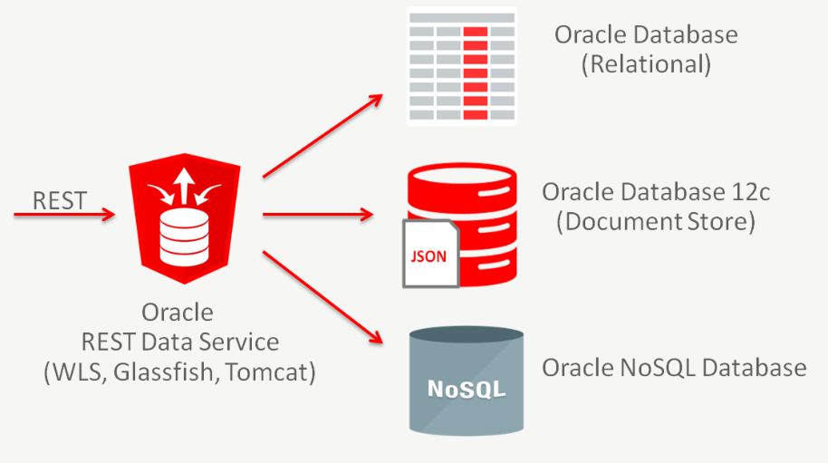

Normally, there are two ways to install **Oracle APEX.**

**Method 1:** Configure the **Embedded PL/SQL Gateway**: This is the way to configure **Oracle APEX**which can run on **Oracle XML DB HTTP Server**, it is a HTTP that is available when you install Oracle 11g or higher.   
  
**Method 2:** Install **Oracle APEX** on a specific web server such as **WebLogic, Tomcat or Glassfish, ...**

Link worked with **Oracle APEX** as followed:

* http://your-server:8080/apex

To use **RESTful**services, you need to install  **Oracle ORDS**which can deploy on  **WebLogic Server**, **Tomcat**, **Glassfish**,.. or independently. **Oracle ORDS** can read directly to **Oracle APEX** and replace completely  **Oracle HTTP Server**, therefore you can use **RESTful** on **APEX**and new URL to work with  **Oracle APEX**.

* http://your-server:8080/ords

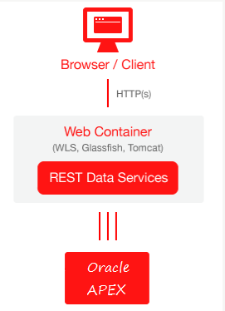

## Download Oracle ORDS

You can download Oracle ORDS at:

* <http://www.oracle.com/technetwork/developer-tools/rest-data-services/downloads/index.html>

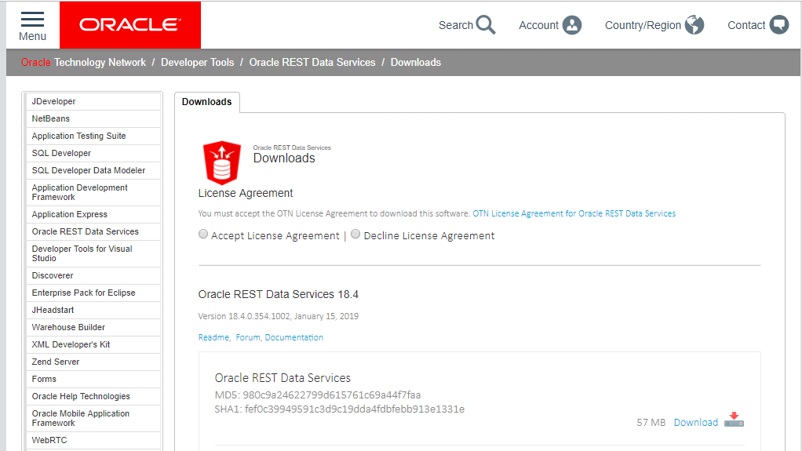

Accept and download

Download results:

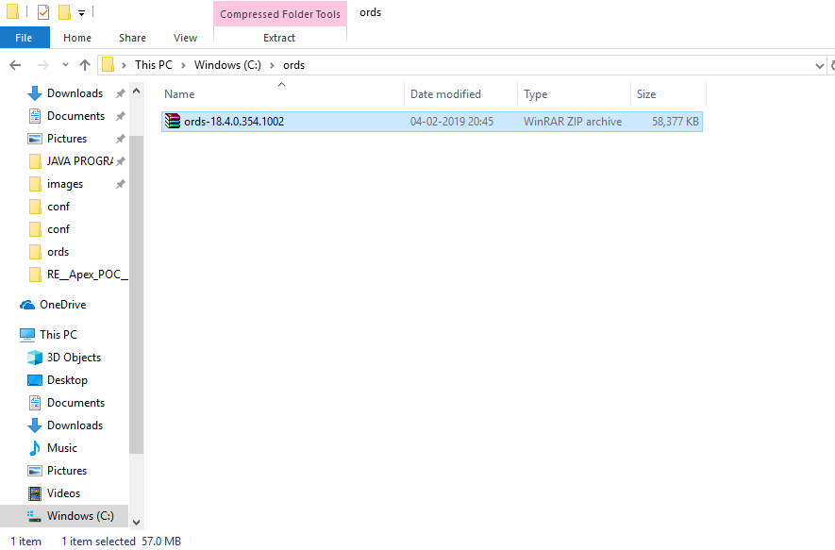

## Config ORDS for APEX

## **CD**to **apex**home directory.

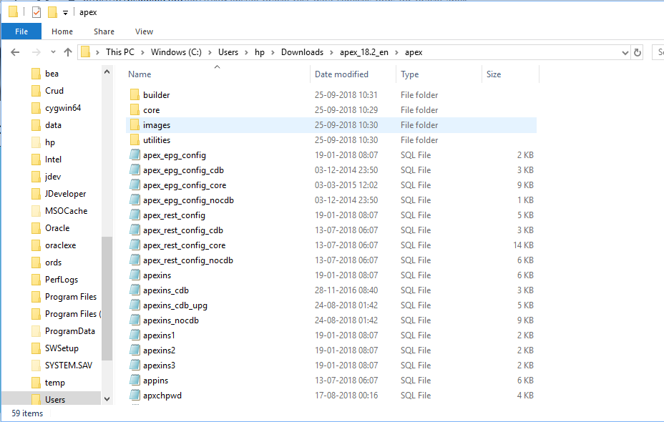

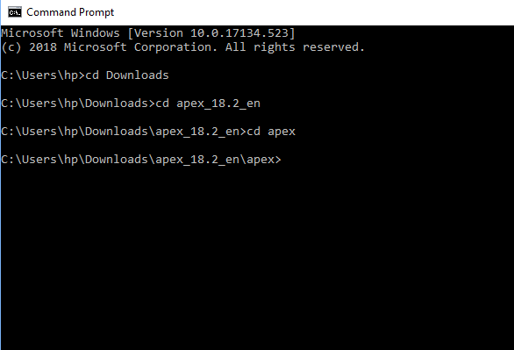

Login to **sqlplus** as **sysdba**.

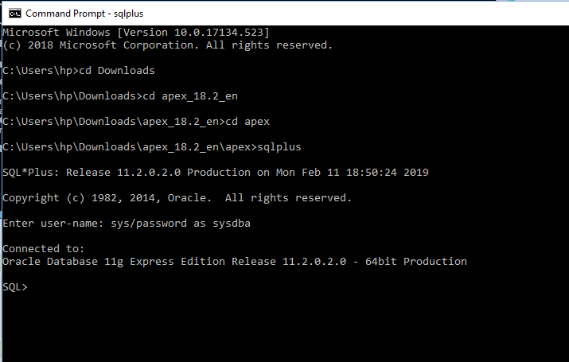

Run the command to configure REST Service.

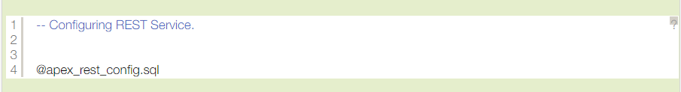

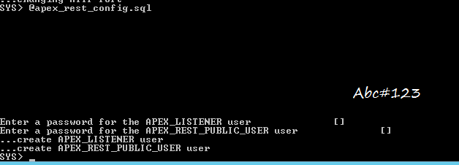Password is anything as our wish.

1. **APEX_LISTENER** - The account used to query RESTful Services definitions stored in **Oracle Application Express**.
2. **APEX_REST_PUBLIC_USER** - The account used when calling RESTful Services definitions stored in **Oracle Application Express**.

### Enable Network Services

By default, Network Services are disable in Oracle 11g or the newer version. Therefore, you must use the package of **DBMS_NETWORK_ACL_ADMIN** in order to to grant connect privileges to any host for the **APEX_** **180200** database user.

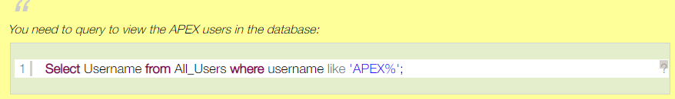

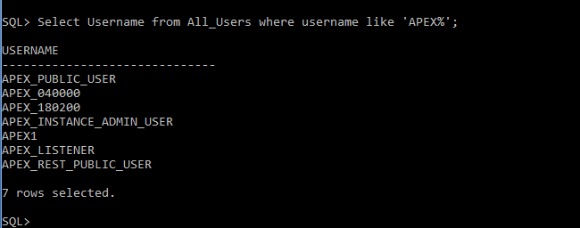

Run command to grant connects privileges to any host for the APEX_180200 database user.

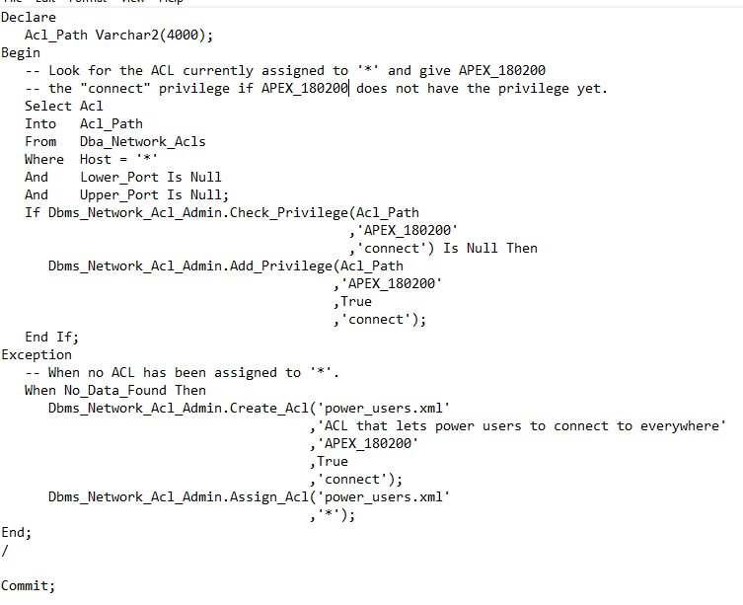

## Deploying ORDS

*Note: you must sure that you have installed Java version 7 or higher and declare PATH variable. You can see how to install Java at:*

* [*Installing and Configuring Java*](https://o7planning.org/en/10377/installing-and-configuring-java)

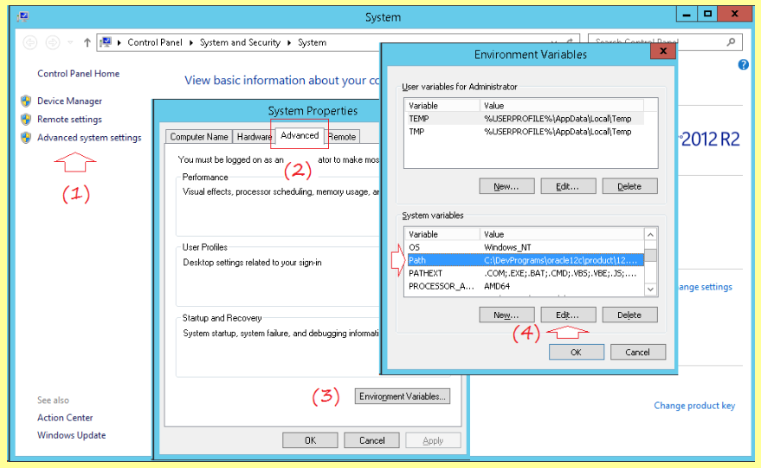

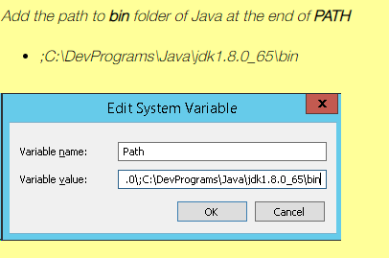

Unzip the file ***ords - **. zip*** that you have downloaded to a folder

You can see that in the folder unzipped have ***ords.war***file.

Copy **images**folder in apex to ords folder:

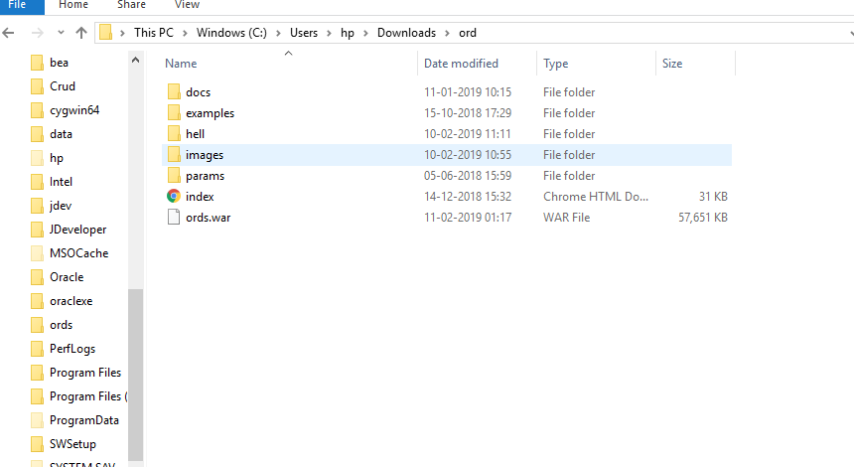

Now, we will install Oracle **ORDS**independently (It is not necessary to deploy on Weblogic, Tomcat or other web server)

**CD**to **ords**folder:

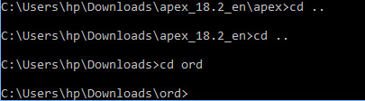

Next, login sqlplus as sysdba.

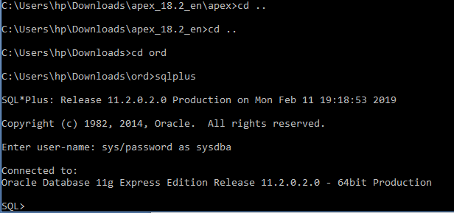

Your **Oracle APEX** is running on **Oracle XML DB HTTP Server**, you should disable it with the command:

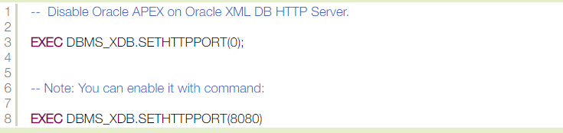

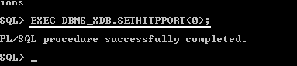

Exit ***sqlplus***. And CD to ords:

Run command:

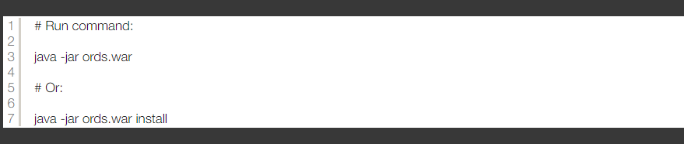

Enter the address of the machine that contains the database (default is localhost):

Port of database (Default is 1521):

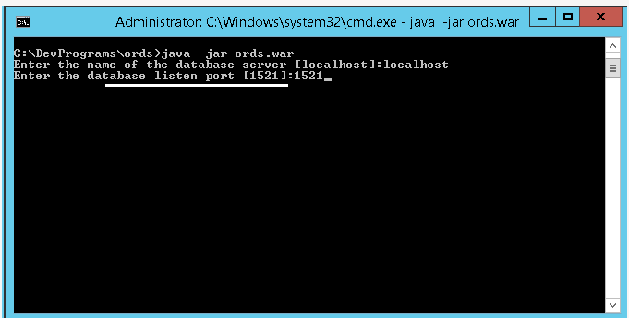

Enter **Service Name** or **SID**of database:

If you want to know database service use below query

SQL> select * from global_name;

Enter password for **ORDS_PUBLIC_USER**

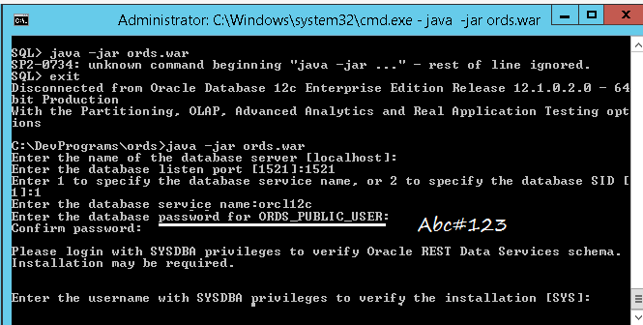

**Sqlplus**requests to re-enter the user database information with **sysdba**rights. (Enter **sys**and then **password**).

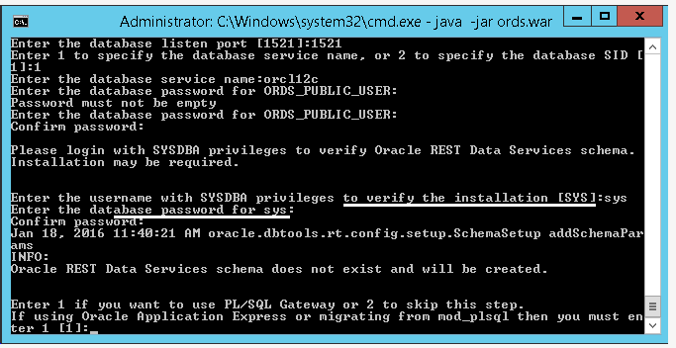

**SQLPlus** will ask whether you use **Oracle APEX**or not, if yes let's enter 1, then press "enter" to continue.

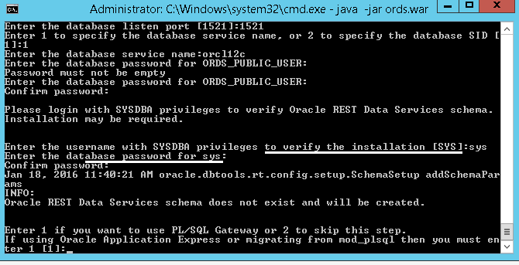

Entering a password for user will be created **(APEX_PUBLIC_USER)**:

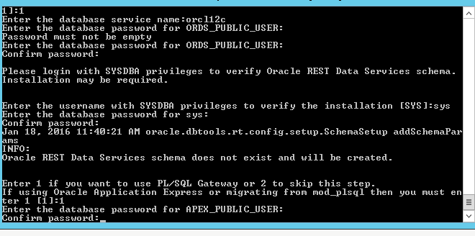

Next, enter 1 to specify password for 2 newly created user database (APEX_LISTENER, APEX_REST_PUBLIC_USER).

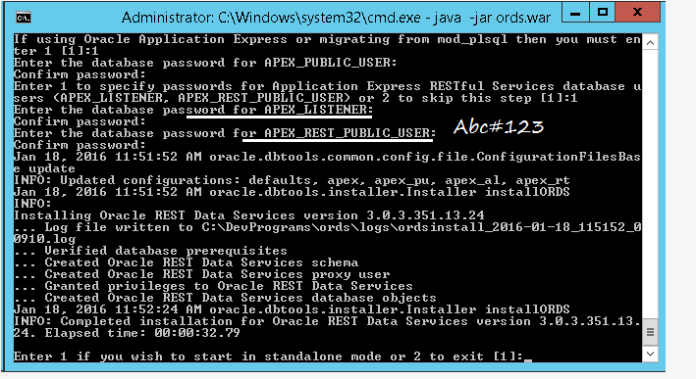

Select 1 to start ORDS in standalone mode:

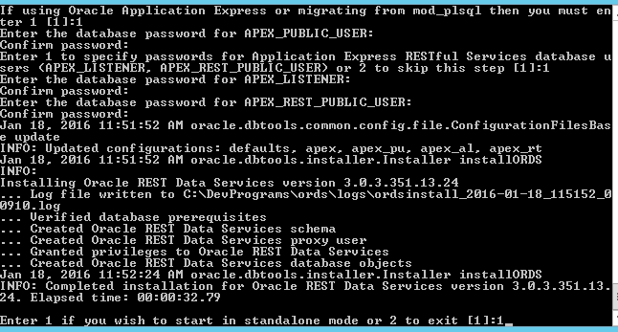

You have configured ORDS successfully. Close CMD window

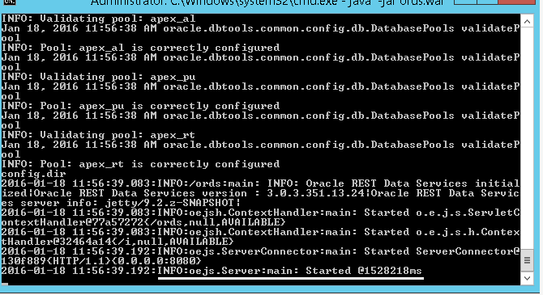

### Running ORDS

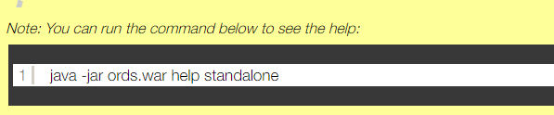

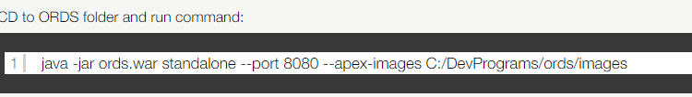

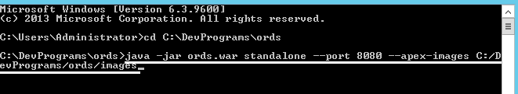

**ORDS**has been successfully deployed.

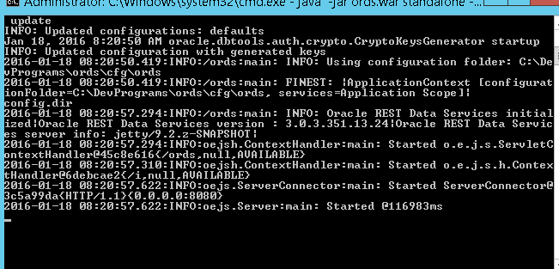

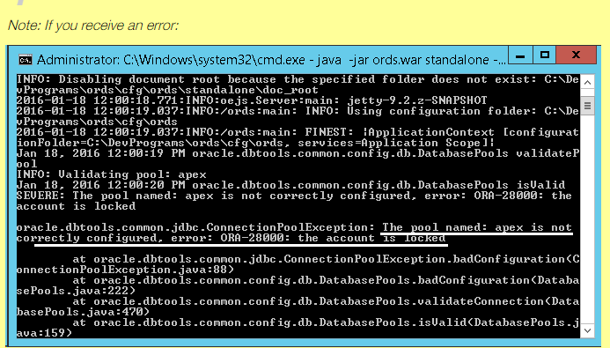

**Go to conf file:**

Unlock four users.

|  |  |
| --- | --- |
| 1 | Alter user APEX_PUBLIC_USER account unlock |
| 2 | Alter user ORDS_PUBLIC_USER account unlock |
| 3 | Alter user APEX_LISTENER account unlock |
| 4 | Alter user APEX_ORDS_PUBLIC_USER account unlock |

The configure file is also created after you deployed ORDS:

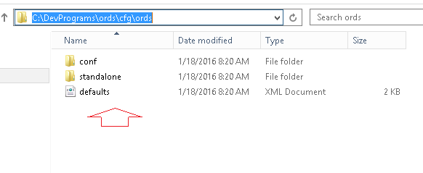

Don't close the window above; you can use APEX with new url:

* <http://localhost:8080/ords>

